**Lab 2 (Part 2)**

13 - Create a folder called myteam in your home directory and change its permissions to read only for the owner.

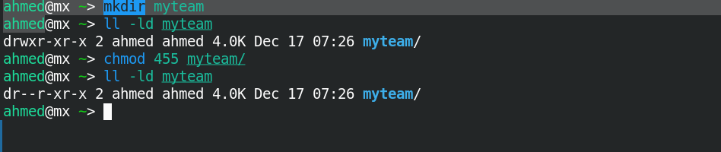

14 - Log out and log in by another user

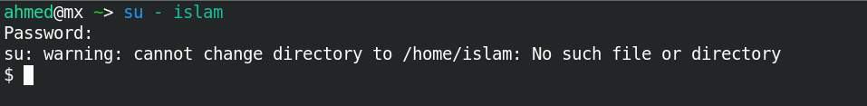

15 - Try to access (by cd command) the folder (myteam)

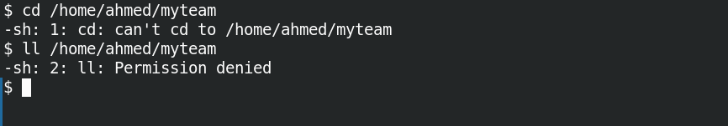

16 - Using the command Line

* + Change the permissions of oldpasswd file to give owner read and write permissions and for group write and execute and execute only for the others(using chmod in 2 different ways).

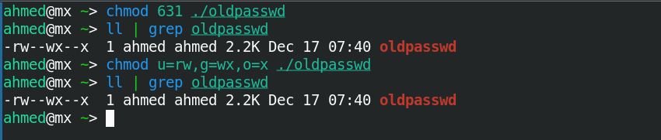

* + Change your default permissions to be as above.

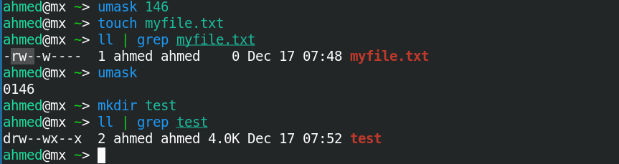

* + What is the maximum permission a file can have, by default when it is just created? And what is that for directory.

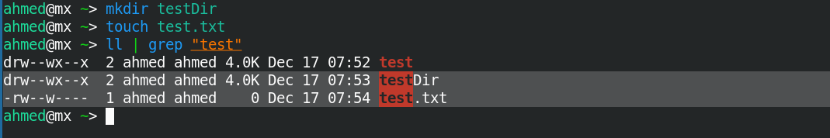

* Change your default permissions to be no permission to everyone then create a directory and a file to verify.

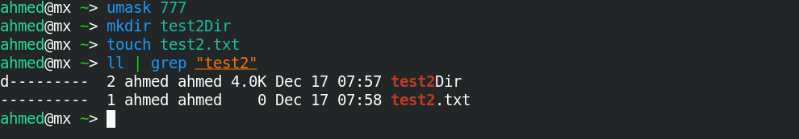

17 - What are the minimum permission needed for.

* 1. Copy a directory (permission for source directory and permissions for target parent directory).

Source directory: rw

Target parent: wx

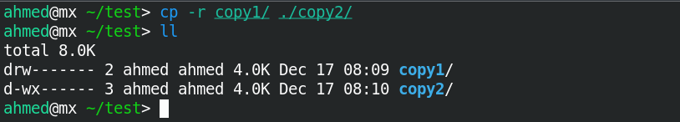

* 1. Copy a file

file : rw , target Dir : wx

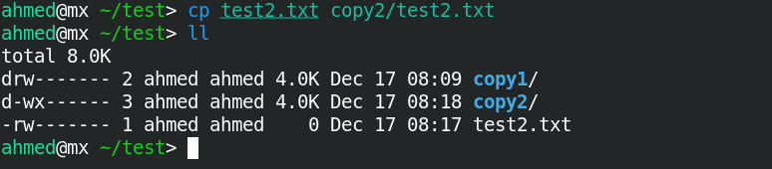

* 1. Delete a file

Directory : wx

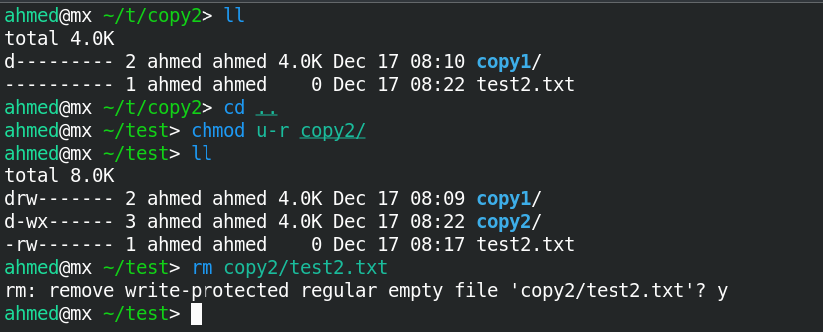

* 1. Change to a directory

Directory : wx

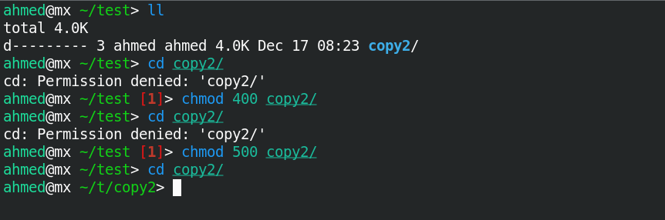

* 1. List a directory content (ls command)

Directory: rx

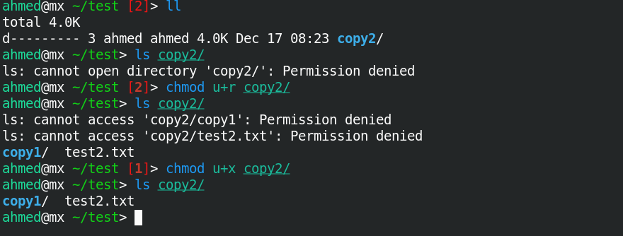

* 1. View a file content (more/cat command)

File : only read permission is required

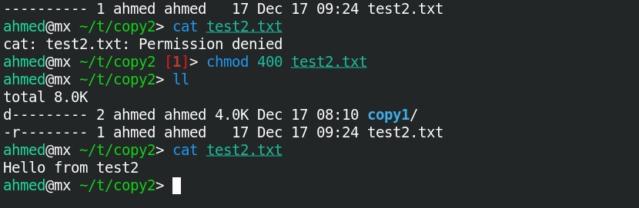

* 1. Modify a file content

File : write only if (using cat to append to file). You can only overwrite to file but can’t append

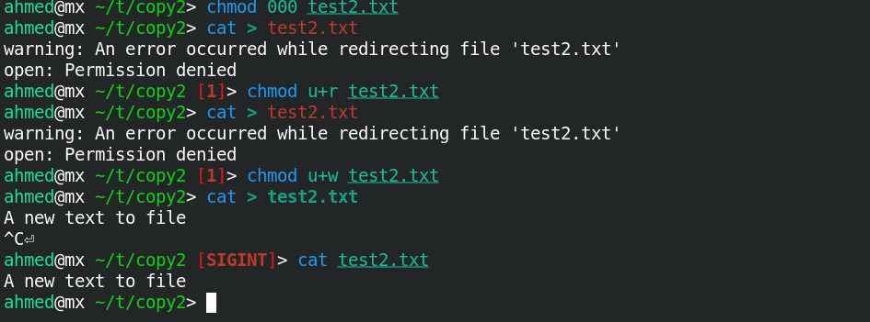

18 - Create a file with permission 444. Try to edit it and to remove it? Note what

Happened.

* File couldn’t be edited or modified but it was removed successfully

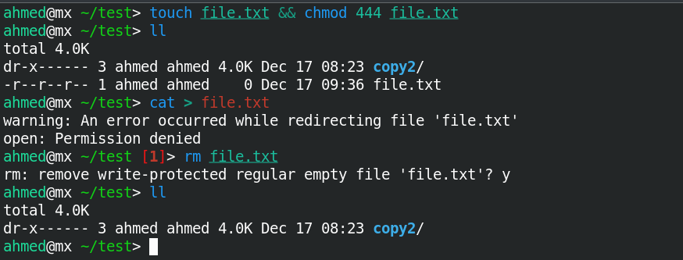

19 - What is the difference between the “x” permission for a file and for a

Directory?

* For a file it makes it executable it can be executed wether it is binary file or sh file.
* For directory it gives the user ability to enter directory



